WEEK 9 LEARNING OUTCOMES

Upon completion of this session, students should be able to:
- Understand the use and application of HTML5 Structural Elements
- Convert existing nested DIV structures to HTML5 Structural Elements
- Use HTML Video element to embed a video file into your HTML pages

Wherever possible, you should try to use tags in compliance with the specification for HTML 5.

Within, this document, tags are shown in capitals for purposes of clarity and emphasis.

Points to remember when creating / using CSS:

1). Your CSS (internal or external) should not contain any html tags.

2). Your CSS should always use the American spelling: COLOR.

3). Your external CSS files should be saved with a .css extension.

4). Pay attention to your document structure when using CSS3

TASK 1: USING ID SELECTORS TO CREATE NESTED DIVS Page 2

TASK 2: ADD APPROPRIATE POSITIONAL PROPERTIES Page 3

TASK 3: USE PSEUDO SELECTORS Page 4

TASK 4: USE CSS3 BORDER RADIUS AND Page 5

TASK 5: USE CSS3 TEXT EFFECTS Page 6

SELF-STUDY TASKS FOR WEEK 7 Page 7

TASK 1: CREATE A NESTED DIV STRUCTURE
Nested DIV structures give flexibility due to the positional values moving us away from the rigidity of static positioning, using values that are relative to parent elements and using percentage widths for resizing (liquid layouts).

1). Use the HTML and CSS below to create a nested DIV structure starting with
wrapper div and a header dive

2). In the first instance, try to replicate the layout shown by adding by creating
CSS for the other nested divs in the document.
<!doctype html>
<html>
<head>
<title>CT4009 WEEK 8</title>
</head>
<body>
<div id="wrapper">
<div id="header"> <h1>THIS IS WEEK 8 OF CT4009 </h1></div>
<div id="content"> THIS IS WEEK 8 OF CT4009</div>
<div id="footer1">THIS IS WEEK 8 OF CT4009</div>
<div id="footer2">THIS IS WEEK 8 OF CT4009</div>
</div>
</body>
</html>
WRAPPER DIV CSS |  | INSTRUCTION / TASK
#wrapper {  padding: 10px;  height: 800px;  width: 850px;  margin-top: 10px;  margin-right: auto;  margin-bottom: 10px;  margin-left: auto;  border: 1px solid #999;} |  | The wrapper div will act as a container for all of the other div elements in the document.  We can use the wrapper div as a reference point (positions / percentage widths) for the divs nested within it.
#header {  padding: 10px;  height: 150px;  width: 95%;  margin-top: 10px;  margin-right: auto;  margin-bottom: 10px;  margin-left: auto;  border: 1px solid #999;} |  | The header div takes its width as a percentage of the parent element which is the wrapper div.  No matter what size the browser window, the header will always be 95% of the wrapper div.  Auto margins centre the header inside the parent element.

TASK 2: USING THE POSITION PROPERTY

Absolute Positioning places the element precisely, relative to the parent element which contains it regardless of any other content.

Relative Positioning places the element with respect to other elements on the page and depends on the default flow of the document.

Fixed Positioning gives elements precise placement relative to the browser window, outside the flow of other content and will not move. As a result, it does not give us the flexibility we require and we should refrain from using it in most circumstances.

1). Use the sample CSS to experiment with Absolute Positioning with the
nested DIV structure.

2). Use the sample CSS to experiment with Relative Positioning with the
nested DIV structure.
<!doctype html>
<html>
<head>
<title>CT4009 WEEK 8</title>
</head>
<body>
<div id="wrapper">
<div id="header"> <h1>THIS IS WEEK 8 OF CT4009 </h1></div>
<div id="content"> THIS IS WEEK 8 OF CT4009</div>
<div id="footer1">THIS IS WEEK 8 OF CT4009</div>
<div id="footer2">THIS IS WEEK 8 OF CT4009</div>
</div>
</body>
</html>
ABSOLUTE POSITION CSS |  | INSTRUCTION
position:absolute;  left:20px; |  | Will position the div to which it is applied 20px in from the left of the parent element.
RELATIVE POSTION CSS
position: relative;  left:20px; |  | Will position the div to which it is applied 20px in from the left of its normal position in the document.

NB Using absolute and relative positions within the nested div structure and CSS given for Task 1 will produce markedly different results and to get it work, you will have to change some of the existing CSS which affects positions.
TASK 3: USE CSS3 PSEUDO SELECTORS

CSS3 allows access to child elements based on their position inside a parent using the: first-child class. This allows us to target an element as the first tag inside its parent element. The selector below would add style to the first paragraph in the example HTML, but not to the second one. We can use the same technique to target the last child of parent element.

The CSS3 structural pseudo classes allow us to move through the document structure and target child elements. The nth-child pseudo class targets elements according to their order within the parent element.

1). Use the :first-child class to target child elements.

2). Use the :last-child class to target child elements.

2). Use the :nth-child class to target child elements.

<!doctype html>
<html>
<head>
<title>CT4009 WEEK 8</title>
</head>
<body>
<div id="intro">
<p>The opening paragraph.</p>
<p>The next paragraph</p>
</div>
</body>
</html>

FIRST CHILD CLASS CSS | INSTRUCTION
div#intro p:first-child {font-size: 110%; } | Target first child elements inside your divs and format with CSS.
ul#navigation li:last-child  {  border-bottom: none;  } | Target last child elements inside your divs and format with CSS.  This example targets the last list item in an unordered list within the navigation div.
ul#navigation li:nth-child(3)  {  border-bottom: none;  } | Target specified number ordered child elements inside your divs and format with CSS.  This example targets the 3rd list item in an unordered list within the navigation div.
TASK 4: USE CSS3 BORDER RADIUS AND TEXT EFFECTS

The CSS3 border-radius property allows you to create rounded corners without the need for corner images or the use of multiple div tags stacked using the z – index to create image/background effects.
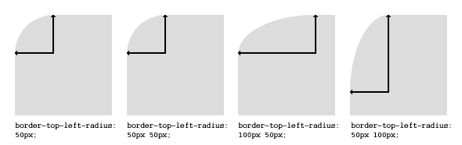

1). Add border-radius properties and values to round the corners of your divs.

2). Change the values to achieve different effects.

3). Add a vendor-prefix for older versions of Firefox.
<!doctype html>
<html>
<head>
<title>CT4009 WEEK 8</title>
</head>
<body>
<div id="wrapper">
<div id="header"> <h1>THIS IS WEEK 8 OF CT4009 </h1></div>
<div id="content"> THIS IS WEEK 8 OF CT4009</div>
<div id="footer1">THIS IS WEEK 8 OF CT4009</div>
<div id="footer2">THIS IS WEEK 8 OF CT4009</div>
</div>
</body>
</html>
CSS |  | INSTRUCTION
#header {  border-radius: 15px;  } |  | Adds a border radius of 15 pixels to the div with an ID of header
#header {  -moz-border-radius: 15px;  border-radius: 15px;  } |  | Add a vendor prefix to all of you border radius declarations to account for older versions of Firefox.
TASK 5: USE CSS3 TEXT-SHADOW PROPERTY

One of the most often wished for properties - text-shadow, which allows easy creation of drop shadows - looks to be popular as new versions of browsers are starting to support the property

Can enhance the look of the textual content in our HTML documents but make sure that you use it sparingly and subtly if possible. Remember – less is more.

1). Apply text-shadow values to level headings.

2). Change values to amend the offset of the shadow.

3). Use in conjunction with Pseudo Selectors to target specific child elements.
<!doctype html>
<html>
<head>
<title>CT4009 WEEK 8</title>
</head>
<body>
<div id="wrapper">
<div id="header"> <h1>THIS IS WEEK 8 OF CT4009 </h1></div>
<div id="content"> THIS IS WEEK 8 OF CT4009</div>
<div id="footer1">THIS IS WEEK 8 OF CT4009</div>
<div id="footer2">THIS IS WEEK 8 OF CT4009</div>
</div>
</body>
</html>
STYLES |  | INSTRUCTION
h1 {  text-shadow: #555 3px 3px 2px;  }  #header {  text-shadow: #555 2px 1px 4px;  }  ul#navigation li:nth-child(3) {  text-shadow: #555 2px 1px 4px;  } |  | This will add a text-shadow to all level one headings where:  The first value after the hex colour indicates the horizontal offset of the shadow.  The second value indicates the vertical offset.  The third value is the blur radius.  Experiment with all 3 values to achieve subtle effects.
SELF-STUDY: CONDUCT FURTHER EXPERIMENTS WITH POSITIONS AND CSS3.
1). Upon Completion of tutorial tasks, experiment further with CSS, positioning <div> tags and elements contained with HTML created thus far. You should try to demonstrate your attempts to use:
- Absolutely Positioned DIVs
- Relatively Positioned DIVs
- Floated DIVs
- Liquid Layouts using %age Width DIVs
- CSS3 Pseudo Selectors
- CSS3 Border Radius and Text Shadow properties

2). Continue to experiment with HTML, adding further content (text and images) to your documents. This should now take place as part of your Portfolio Website.

3). Experiment with the formatting possibilities of CSS, demonstrating these differences and illustrating the techniques within your HTML.

4). Use these tools and techniques to create initial prototype layouts for you portfolio site.
Good introductory material and practical exercises can be found at:
http://www.w3schools.com/css/default.asphttp://www.csszengarden.com/ http://meyerweb.com/eric/css/edge/
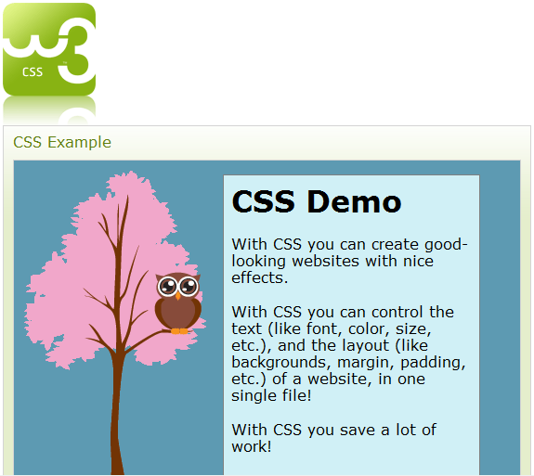
You should also take screengrabs of your HTML, the CSS which you create and the resultant documents (as rendered via a browser) and integrate these into Evaluation Document. The illustration and discussion of code can be difficult to present effectively, so ensure that you have looked at the Evaluation Document Guidelines available on the module website.

If you have successfully completed the Tutorial Exercises, you could spend the remaining study time reading the recommended textbook. Alternatively, you could review this week’s lecture notes or look ahead to next week’s topics. Remember that you are free to use the labs as long as they are not booked for another lesson; they tend to be very quiet early in the morning and in the evenings!

It is important that you read through the module guide several times throughout the semester so that you have a thorough understanding of the requirements of the module, particularly the assignments.

Starting planning your portfolio for assignment 1 by considering things such as what media you may already have that could be included, e.g. photographs etc. Are these available locally? Do they need to be scanned or digitised? If you do not have your own digital camera or camcorder you should think about borrowing these from the technicians – plan for this by booking in advance. Also, it would be appropriate to keep a written diary of your html / authoring experiences so that you can use them later on in the assignment and include them in your Evaluation Document. This could be rough notes, sketches or possibly screen shots, add to them as thoughts come to mind – it is too easy to forget excellent ideas you had late at night or early in the morning!

NB: If you did not manage to complete all of the tutorial exercise in the time available during your allotted lab session, you must endeavor to catch up during the self-directed study time.

